**An Interpretable Machine Learning Model for Gender Prediction using SHAP and Class Activation Maps (CAMs)**

Columbian College of Arts & Sciences

The George Washington University, Washington D.C.

**Students**:

Renzo Castagnino

**Professor**: Amir Jafari

**Date**: December 2020

**Keywords:** Interpretability, Class Activation Maps, SHAP, Integrated Gradient, Convolutional Neural Networks.

**Abstract.** *Interpretability has become vital in machine learning, and research on this topic is currently trending. Interpreting and explaining machine learning model is important to identify bias, ensure fairness and transparency. This paper proposes an interpretable machine learning model for gender recognition. The importance of this research arises because gender recognition is crucial in social interactions with intelligent applications. The data used in this project is the CelebA dataset, containing over 200,000 celebrity images with their corresponding attributes, including gender. To achieve this task, the project will use three pre-trained models of convolutional neural networks: VGG-16, Inception V3, and ResNet. To tackle the black-box problem, class activation maps and integrated gradient will be applied to the pre-trained models to uncover meaningful insights. The results demonstrate that there is a substantial difference between the three pre-trained models. While VGG-16 focuses on specific features of the face, Inception and ResNet focuses on the overall face attributes.*

**Table of Contents**

2. Introduction 4

3. Main Problem 5

4. Class Activation Maps (CAMs) 5

5. Integrated Gradients 5

6. Dataset 6

7. Experimental 6

8. Results 8

9. Conclusions 15

10. References 15

11. Appendix A 17

# Introduction

Machine learning is a set of methods and techniques that computers use to learn and make predictions based on data [1]. Its main goal is to allow computers to learn automatically and take decisions without human intervention. A machine learning algorithm learns a model by estimating parameters or learning structures. This is measured by a score or loss function that is usually minimized. Thus, one of the most important aspects to consider is the accuracy of the model. However, trusting the model performance could lead us to ignore why the model is making certain decisions. This means that a single metric like accuracy is not a complete description of the model [2]. In certain cases, knowing why the model made a decision can help to understand deeper the problem, as well as the data and why a model might not perform better. Machine learning is playing an important role in real-world tasks and explaining why a machine learning model made a decision is crucial. As these complex algorithms are used more often in our society, there is a surge of research in understanding their behavior and provide explanations of their decisions at a deep level of detail.

Interpretability arises from an incomplete way of evaluating a model, to understand how it came to the prediction. According to Miller [3] interpretability is the degree to which a human can understand the cause of a decision. To facilitate learning, understand why predictions or behaviors are created by the machines, interpretability is crucial. Nowadays, machine learning is playing an important role in real-world tasks, and explaining why a machine learning model made a decision could be crucial. For instance, if a model is getting biases from the training data, your model predictions might discriminate based on demographics. This problem can’t be solved by the loss function.

The importance of this research arises because gender recognition is important in social interactions with intelligent applications. According to the World Economic Forum [4], many current machine learning applications might not seem relevant to human rights, such as the image recognition systems used to tag photos on social media. However, it is easy to conceive scenarios in which they become so. Image recognition can, for instance, identify a person’s sexual orientation with reasonable accuracy. Discriminatory outcomes not only violate human rights, but they also undermine public trust in machine learning.

Current solutions to explain machine learning models such as decision trees or Bayesian Rule List [5,6], that discretize a high-dimensional feature space into simple decision statements, are meaningful because their components can be examined directly. Given that the number of internal components is not complex (i.e., rules), this approach can be advantageous. However, models such as neural networks or random forest with numerous trees, that are black-boxes, can be cumbersome. Another alternative to tackle this problem is to be model-agnostic, by extracting post-hoc [7]. CNN have demonstrated to have a superior performance object detection and classification. However, there is no clear understanding of why they perform so well, or how they might be improved [8, 9]. These explanations are important to ensure the rightfulness of the model and to make sure is not biased.

# Main Problem

A common concern of a machine learning model is the “black-box problem”. This means that a machine learning model can be unclear and confusing to the users, with lack of understanding or interpretation. Therefore, it is not possible to assess or make sense of the decisions made by the model. Interpretability in many cases can provide insights of these model, producing helpful explanations. This project will use 2 interpretability models to try to understand how a pre-trained model is classifying 2 different classes, and interpret the feature importance that led to that decision.

# Class Activation Maps (CAMs)

CAMs is a technique to identify discriminative image regions that denotes the feature importance produced by CNN to identify a class. This paper will be based on CAMs using *global average pooling*. More specifically, as described by Zhou et al. [15], let $fκ\left(x,y\right)$ represent the activation of unit *k* in the final convolutional layer at a spatial location (*x, y*). After that, applying global average pooling for the unit k, F*k* is $\sum_{x,y}{fκ}(x,y)$. Therefore, for a class *c*, the input of the Softmax $Sc$*is $\sum_{k}{w_{k}^{c}Fκ}$* where $w_{k}^{c}$ is the weight corresponding to class *c* for unit *k.* The importance of $Fκ$ for class *c* is represented by $w_{k}^{c}$. Thus, the output of the Softmax for the class *c*, *c* is given by:

$$\frac{exp⁡(Sc)}{\sum_{c}{exp⁡(Sc)}}.$$

Additionally, the input bias for the Softmax is set to 0 due to its insignificant effect on classification task. By applying

$$Fκ= \sum_{x,y}{fκ(x, y)}$$

In the class score $Sc$, we get

$$Sc= \sum_{k}{w_{k}^{c}}\sum_{x,y}{fκ(x,y)}= \sum_{x,y}{\sum_{k}{w_{k}^{c}f_{k}\left(x,y\right).}}$$

We also define $Mc$ as the class activation map for the class *c*, where the spatial elements are given by

$$Mc\left(x,y\right)= \sum_{k}{w_{k}^{c}f_{k}\left(x,y\right).}$$

Therefore, $Sc= \sum_{x,y}{Mc(x,y)}$, and $Mc(x,y)$ indicates the importance of the activation spatial grid $(x,y)$ producing the classification of an image to class *c*. The CAM is a weighted linear sum of the presence of the visual patterns in different spatial locations [15].

# Integrated Gradients

This project will be based on the methodology proposed by Sundararajan et al. [22]. If we represent our deep network as a function $F:R^{n}→[0,1]$, let $x ∈R^{n}$ be the input, and $x^{'}∈ R^{n}$ be the baseline input. Consider as a baseline a black image. Then, from the baseline $x'$ to the input $x$, we consider a straightline path in $R^{n}$, and calculate the gradients in all points along the path. The *integrated gradients* are calculated by accumulating all these gradients. More specifically, integrated gradients are defined as the path integral of the gradients along the straight-line path from the baseline $x'$ to the input $x$ [22].

The integrated gradient (IG) along the $i^{th}$ dimension for an input $x$ and baseline $x'$ is defined by:

$${IG}_{i}\left(x\right)∷=\left(x_{i}-x_{i}^{'}\right) × \int_{α=0}^{1}{\frac{∂F(x^{'}+ α×\left(x-x^{'}\right))}{∂x_{i}}dα}$$

Where $\frac{∂F(x)}{∂x_{i}}$, is the gradient of $F(x)$ along the $i^{th}$ dimension.

# Dataset

The data used in this paper will be based on the large-scale CelebFaces Attributes (CelebA) dataset proposed by Liu et al. [18]. This dataset contains more than 200K celebrity faces images, each with 40 attribute annotations including gender.

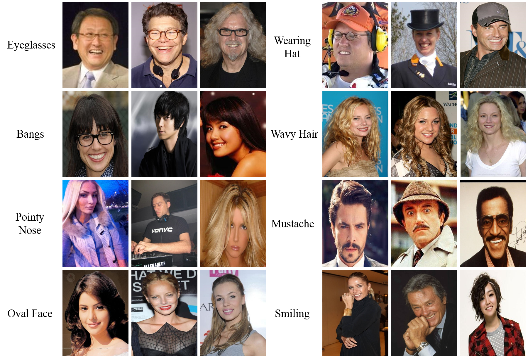

Fig. 1. CelebA dataset sample of faces that will be used during the training process.

The data has 202,599 sample face images aligned and cropped that were used as input to the CNN. There are 118,165 female images and 84,439 male images. For the purpose of this project, the data was first separated between male and female, and then the female category was downsampled to 84,439 images to have the same number of images for both categories. A train-test split of 80% and 20% respectively were considered for the training and testing.

# Pre-trained Models

This project will use three state-of-the-art deep learning architecture models that have demonstrated great accuracy in the ImageNet Large Scale Visual Recognition Challenge (ILSVRC). The first one is VGG-16 proposed in 2014 [19], which receives an input of 224x224 RGB image. This image goes through a series of 16 convolutional layers, with all the kernels of size 3x3, and max-pool kernels of 2x2. Due to its uniform architecture, this network is currently one of the most popular for extracting features from images. However, its 138 million parameters could become difficult to manage. For our project, this model was fine-tuned by freezing the first 24 layers while training the remaining ones. A batch size of 64 was used for the training and testing, with a learning rate of 0.001. Due to computing capacity, the model was trained on 10 epochs.

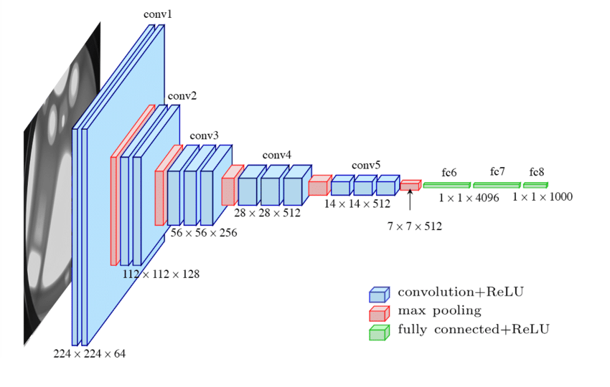

Fig. 2. VGG-16 diagram.

The next pre-trained model is the Residual Neural Network (ResNet), winner of the ILSVCR in 2015. Proposed by He et al. [20], this network introduces the *skip connection*, which addresses the vanishing gradient problem.

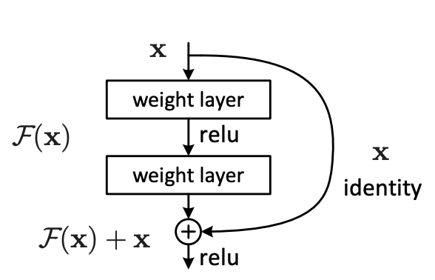

Fig. 3. A building block of residual learning.

In figure 3, the output $H\left(x\right)=F\left(x\right)+x.$ Where the weight layers are used to learn a residual mapping from $F\left(x\right)=H\left(x\right)-x$.

To train this model, we update the model parameters only after the 45th layer, with a batch size of 64 for the training and testing. The training was performed over 10 epochs with a learning rate of 0.001.

The third pre-trained model is Inception v3 [21], winner of the 2014 ILSVCR. This network differs from VGG-16 and ResNet because it contains 1x1 convolution at the middle of the network, that serves as a dimension reduction module that allows to tackle computational bottlenecks. This allows not only to increase the depth, but also the depth of the network without significant performance penalty [21]. Moreover, instead of using a fully connected layer at the end of the network, it applies *global average pooling*.

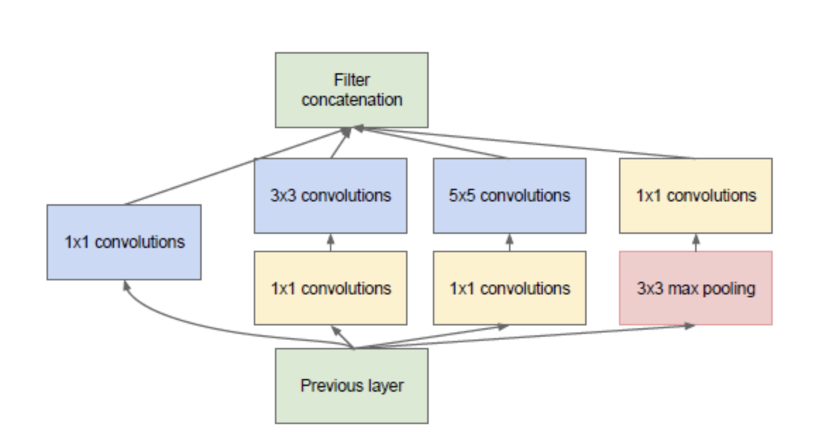

Fig. 3. Inception module with dimensionality reduction

In general, an Inception network is a network consisting of modules of the above type stacked upon each other, with occasional max-pooling layers with stride 2 to halve the resolution of the grid [21]. This model was fine-tuned after the 200th layer, with a training and testing batch size of 64. The model was trained with a learning rate of 0.001 over 10 epochs.

# Results

As a result of training our VGG-16 model, we can observe in figure 4 a training accuracy of 97.6%, with a validation accuracy of 98.2%. In terms of the training loss, a value of 0.05 was obtained, with a validation loss of just 0.07.

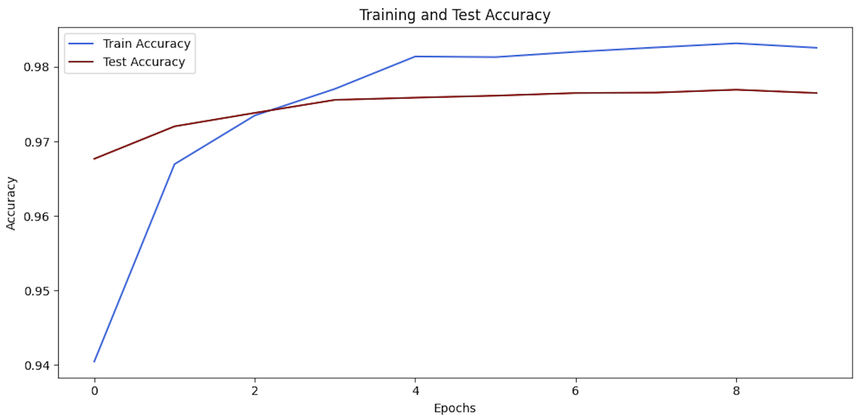

Fig. 4. Results of training accuracy and testing accuracy for VGG-16 on 8 epochs.

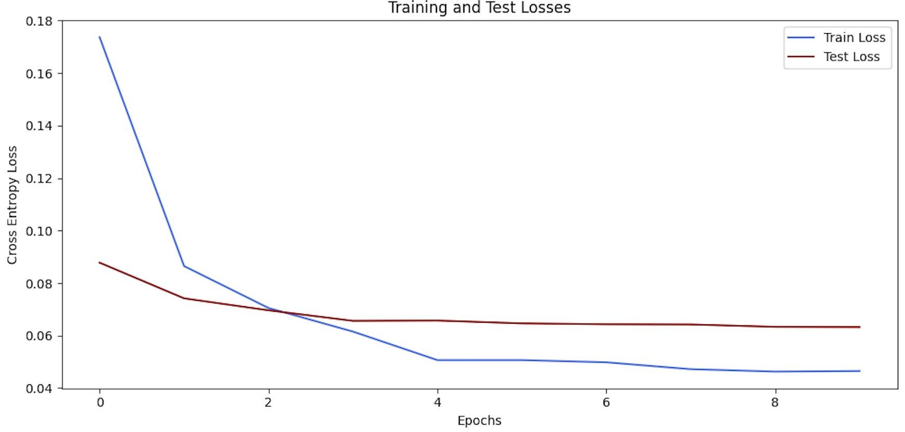

Fig. 5. Results of training and testing loss for VGG-16 on 8 epochs.

In the case of ResNet-50, the training accuracy results in 98.1%, and test accuracy of 97.9% (figure 6). For the training loss the result was 0.058 and for the test loss 0.054 (figure 7).

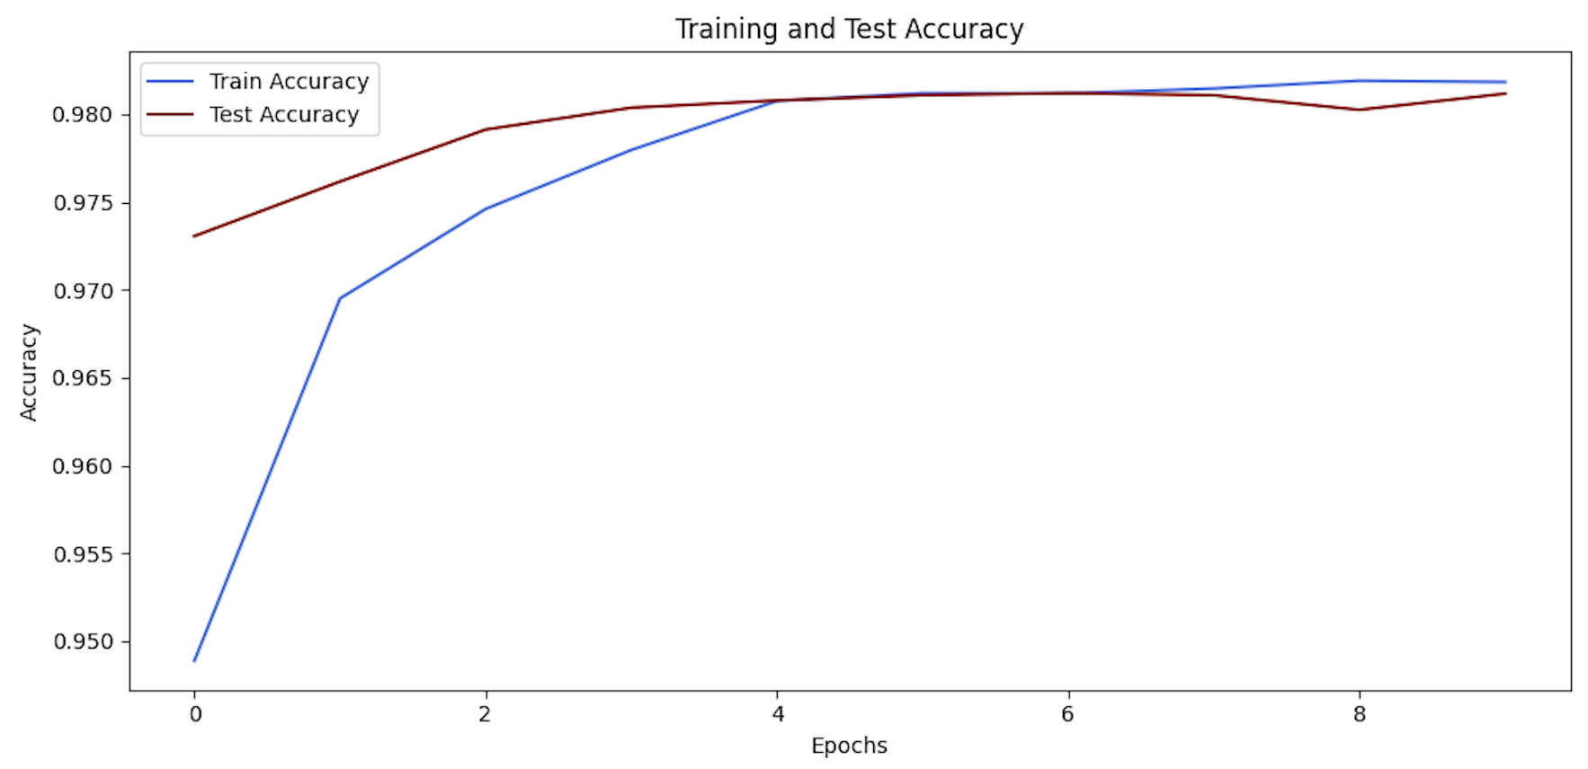

Fig. 6. Results of training accuracy and testing accuracy for ResNet on 8 epochs.

The third pre-trained model was Inception v3. In figure 8 we can observe a training accuracy of 98.3%, and a validation accuracy of 97.5%. In terms of the loss, in figure 9 we can observe a result of 0.051 for the training and 0.072 for the testing.

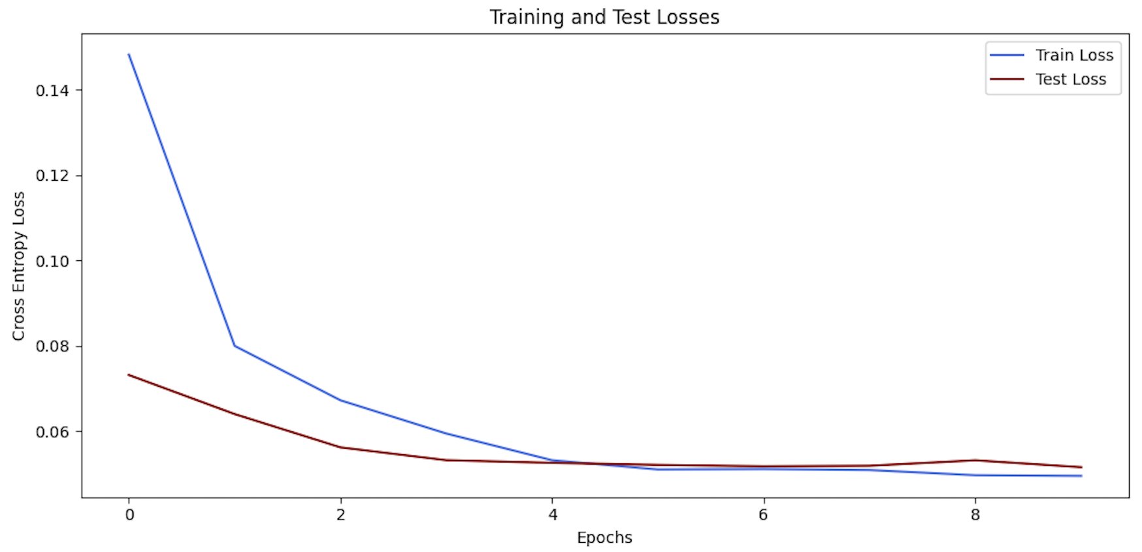

Fig. 7. Results of training loss and testing loss for ResNet on 8 epochs.

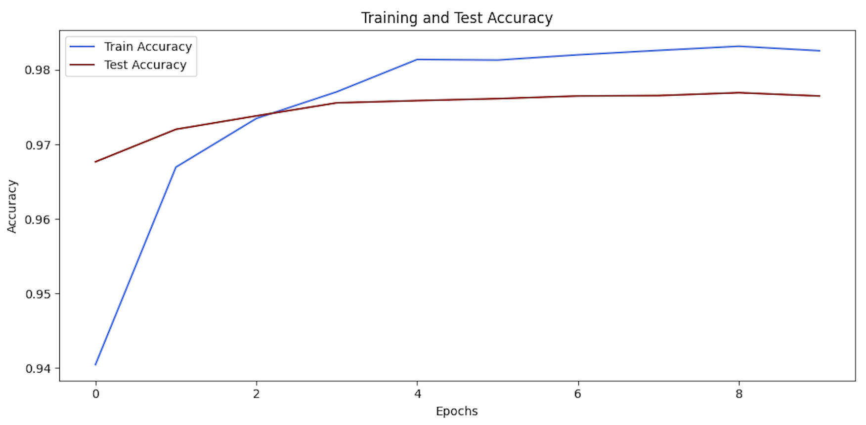

Fig. 8. Results of training accuracy and testing accuracy for Inception v3 on 8 epochs.

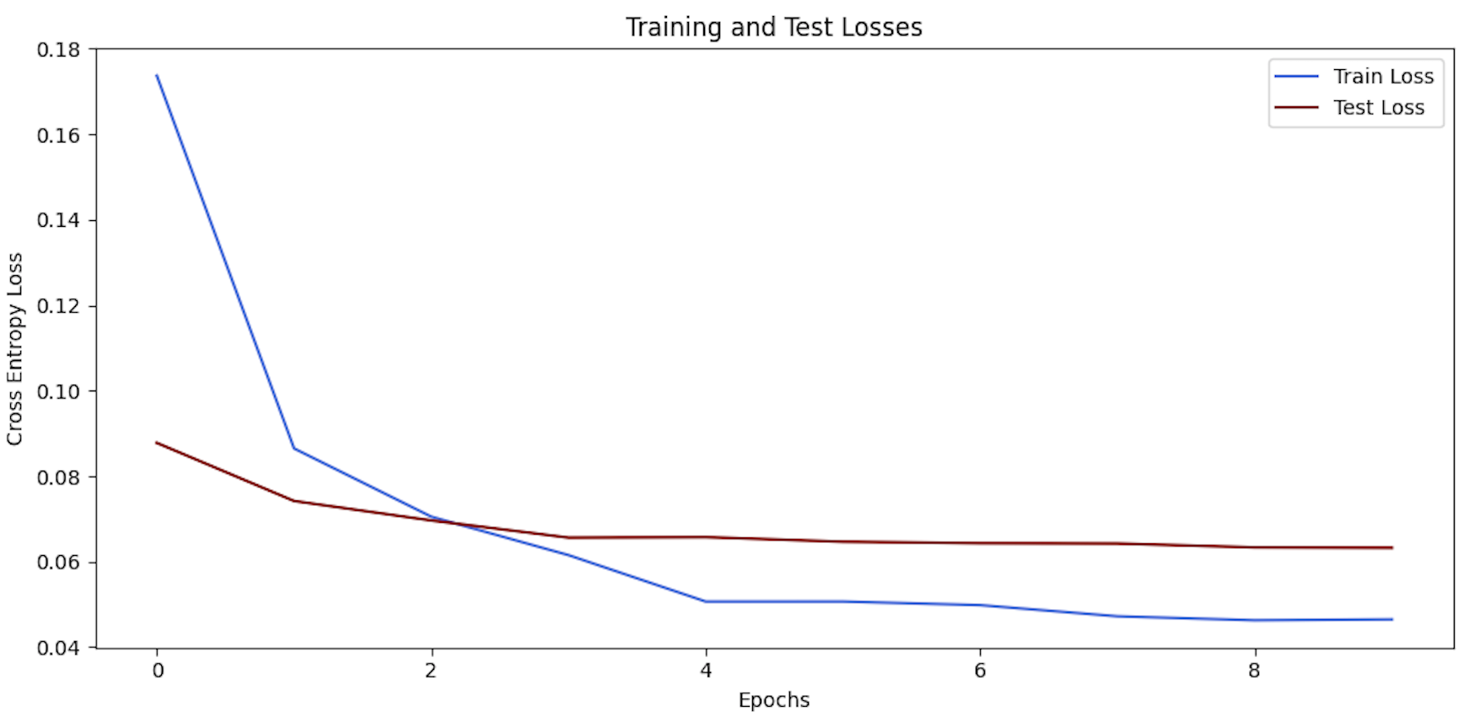

Fig. 9. Results of training and testing loss for Inception v3 on 8 epochs.

To explain how these black-box models are making classification decisions, CAM allows us to see the pixel importance for each image. In figure 10 we can observe the results of CAM’s for the three pre-trained models with their corresponding Softmax values. For VGG-16, we observe how the pixel importance focuses more on specific features (i.e., eyes and chin).

Another important aspect to highlight is that the model performs better on whiter color skin. For instance, the third image in figure 10 was wrongly classified; the Softmax result was 0.024 for VGG-16, followed by 0.859 and 0.731 for Inception and ResNet respectively. Furthermore, the saliency map for Inception and ResNet tends to give high feature importance to the overall face, which differs from VGG-16 that localize specific image regions.

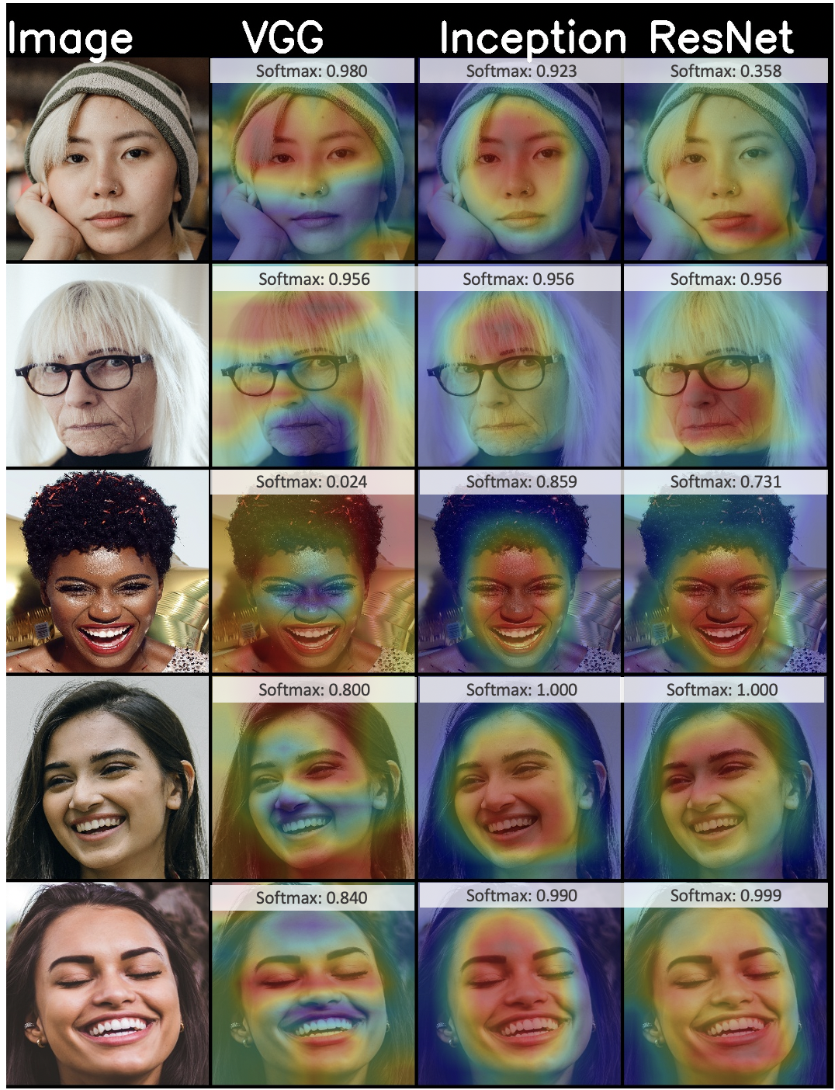

Fig 10. Results of applying class activation maps of the 3 pre-trained models for the female class with the corresponding Softmax result.

In the case of the CAM results for the male category, in figure 11 we observe that the prediction importance for VGG-16 is not as isolated as the female category. For instance, in all the male images VGG-16 gives high importance to the forehead and the mouth. Moreover, another important characteristic to notice is that Inception is focusing predominantly on the mouth, whereas for the females it was on the entire face. Finally, for ResNet, the results are consistent and similar to the female category. In terms of the Softmax metrics, the probability of all the predicted classes is high.

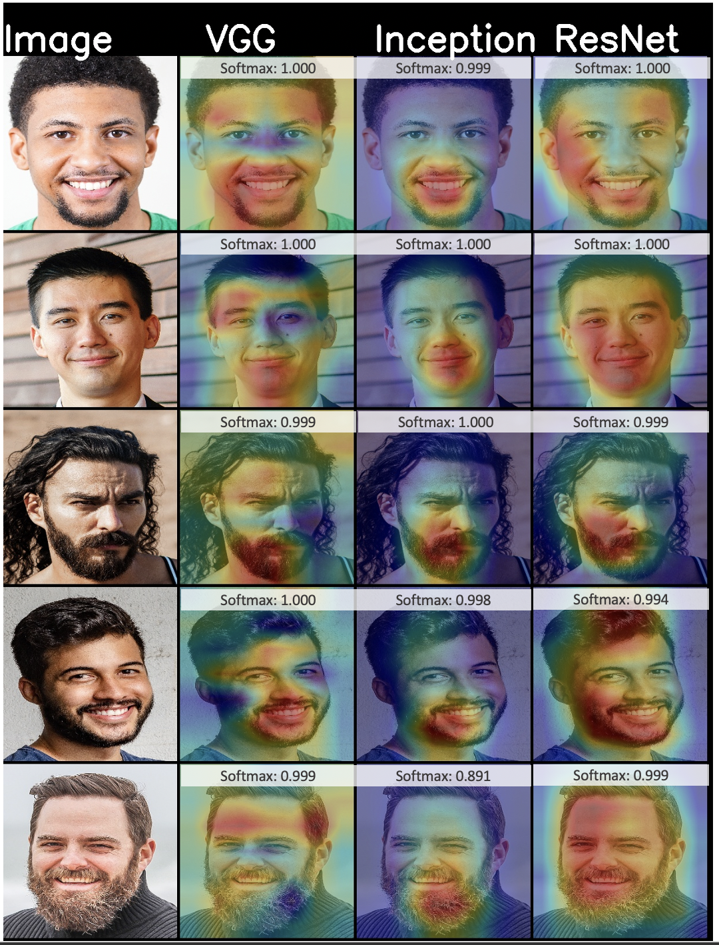

Fig 10. Results of applying class activation maps of the 3 pre-trained models for the male class with the corresponding Softmax result.

Subsequently, for SHAP with *integrated gradients* (fig. 10, 11, and 12), we can interpret the results with the color red as high important features for the predicted category, and blue color for the features of the non-predicted category. We are going to highlight a few examples, the full results can be seen in appendix A.

In figure 10, we observe that for VGG-16, the most important area for the SHAP is pixelated around the eyes (on red). In contrast, Inception tends to focus the feature importance not only on the eyes but also on the chicks and the mouth. For ResNet, the importance map covers all the regions of the face. Similar results are shown in figure 11 for a different sample image. However, this sample was misclassified by VGG-16, while it was correctly predicted by Inception and ResNet.

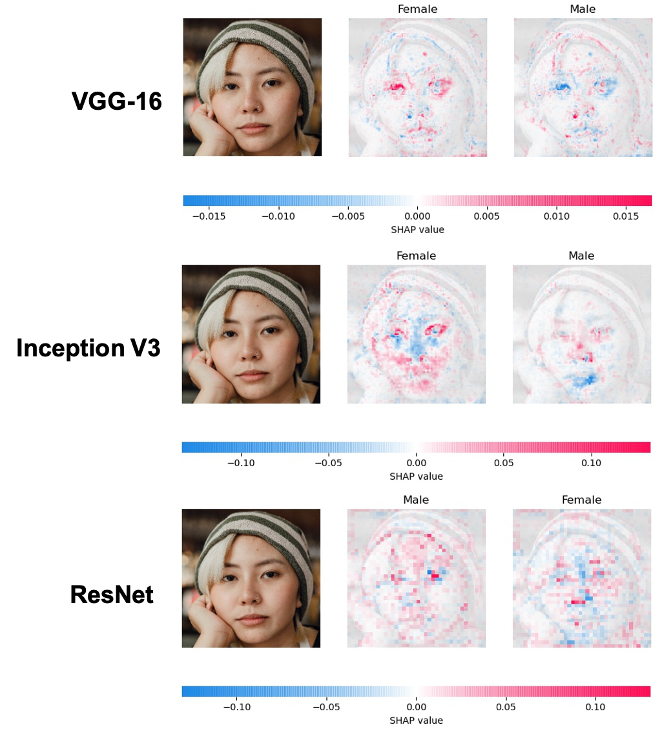

Fig. 10. SHAP Results for the female category, sample 1.

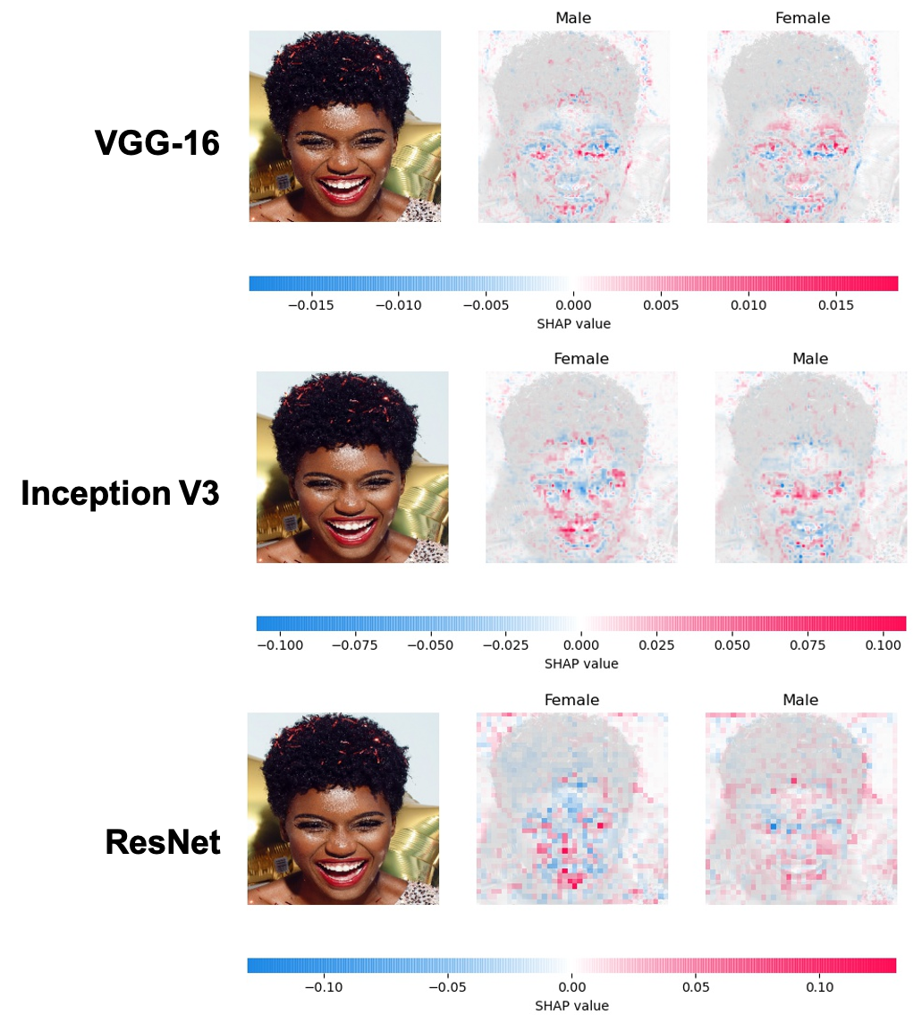

Fig. 11. SHAP Results for the female category, sample 2.

On figure 12 we can observe the results for the male category. In the case of VGG-16, there is a slight focus on the eyes and the beard. In contrast, Inception is showing more the area of the nose. ResNet tends to focus more on the eyes which differs from the female category that gives higher importance to the entire face.

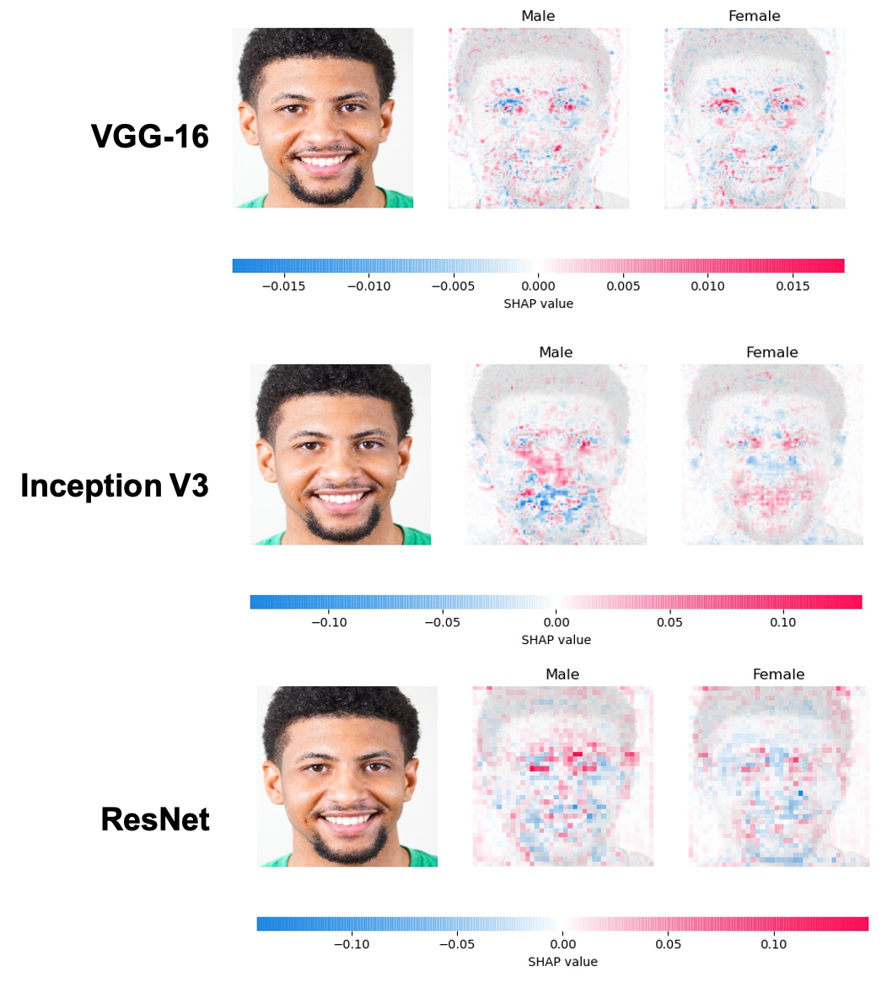

Fig. 12. SHAP Results for the male category, sample 3.

Similarly, figure 13 shows how VGG-16 generates higher importance on the beard area, while Inception focuses on the nose and ResNet on the eyes. It is worth to mention that the pattern of how the feature importance is represented by each pre-trained model is the same for all the samples in our experiment. VGG-16 is very specific on capturing the eyes, while for Inception and ResNet the feature map captures the entire face.

In addition, we can compare the weighted activation maps with the SHAP results. In figure 14 we observe how VGG-16 identifies consistent face parts like eyes and lips. This characteristic of the model can be confirmed in the SHAP results,

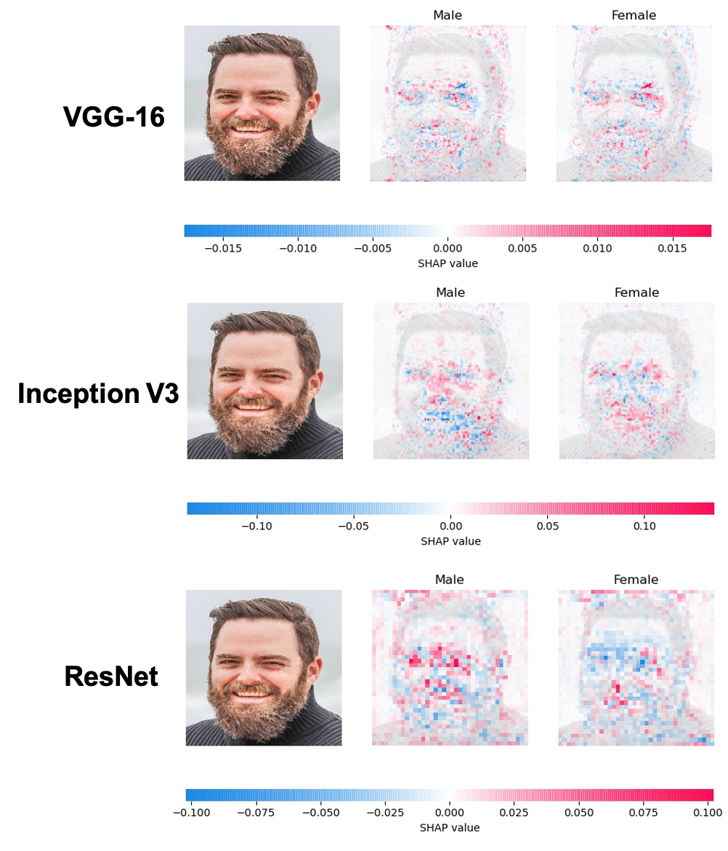

Fig. 13. SHAP Results for the male category, sample 4.

where we can see which pixels contributed the most to the image prediction.

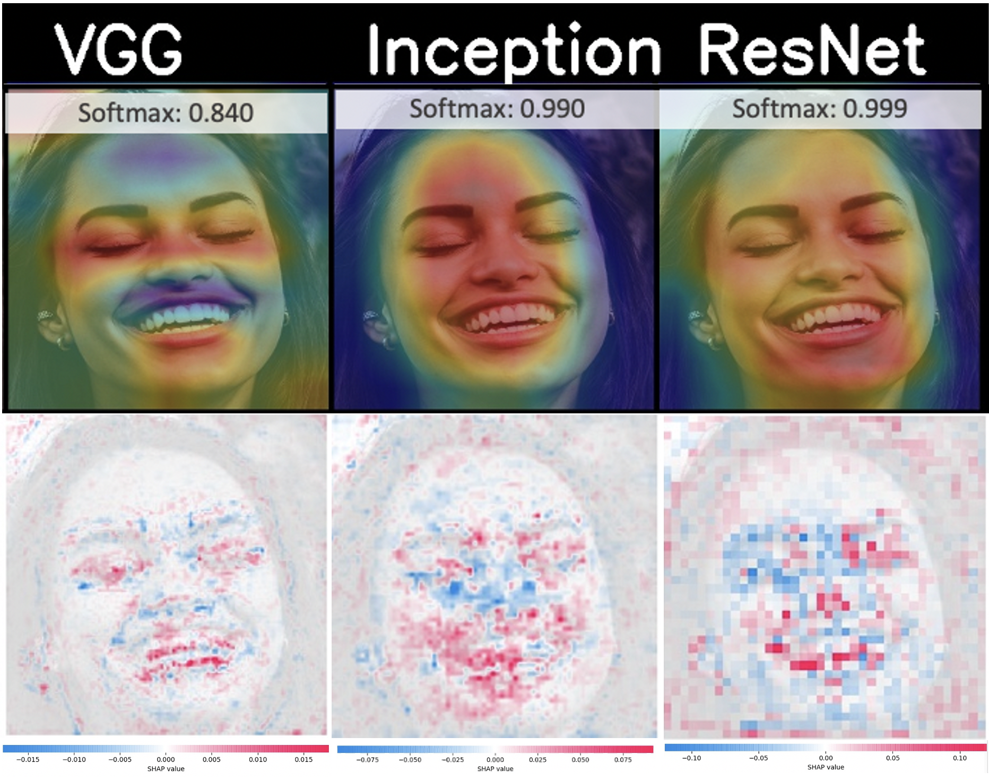

Fig. 14. Comparison between CAM heatmap vs SHAP values for the female category.

Finally, one last thing to observe is that not for all the samples the results of CAM and SHAP were consistent. For instance, in figure 15 it can be seen that the heated map for VGG-16 focuses on the forehead and the chin. In contrast, the SHAP values are capturing the overall face with some consistent parts on the eyes and under the nose. Also, the CAM results for Inception are highlighting the mouth, while the SHAP results are highlighting the nose and the area under the eyes.

To conclude, the saliency map for ResNet comprehends the entire face, while SHAP values are focusing predominantly on the upper part of the eyes.

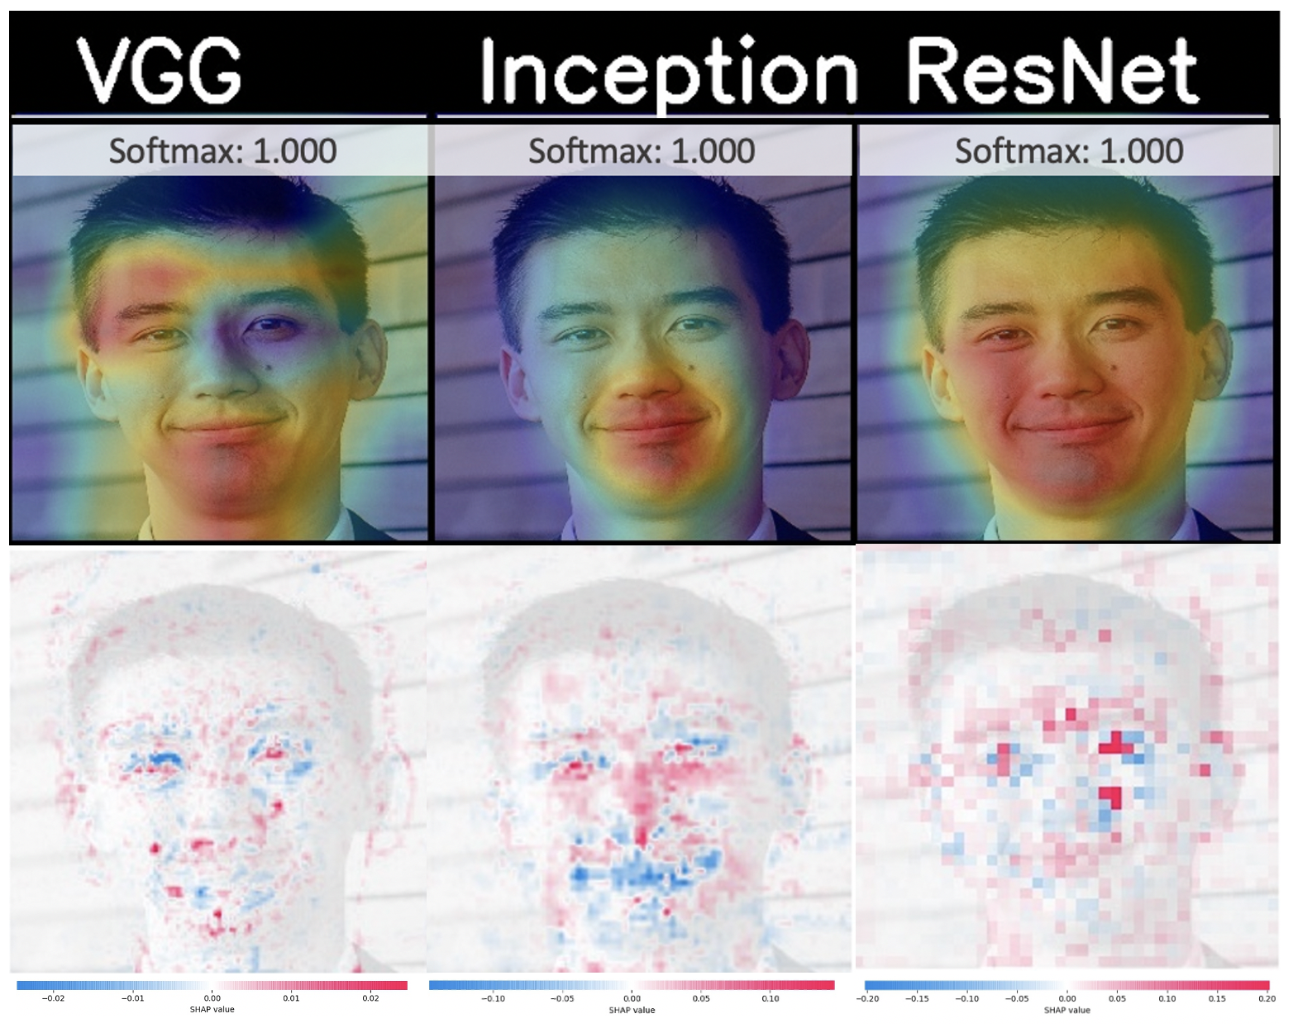

Fig. 15. Comparison between CAM heatmap vs SHAP values for the male category.

# Conclusions

Interpretability arises from an incomplete way of evaluating a machine learning model. Modern interpretability techniques such as class activation maps, or SHAP can provide insights on the feature importance across the training data. These could be useful to detect bias and debug the model. You can also identify features with lower importance, making your model more efficient. However, interpretability by itself can also be difficult to interpret. As we have seen, while some results were consistent for both class activation maps and SHAP, other examples had demonstrated discrepancies between these two techniques.

# References

1. Molnar, C. (2018). Interpretable Machine Learning:A Guide for Making Black Box Models Explainable. Retrieved from <https://christophm\.github.io/interpretable-ml-book/>
2. Doshi-Velez, Finale, and Been Kim. 2017. “Towards A Rigorous Science of Interpretable Machine Learning,” no. M1: 1–13. <http://arxiv.org/abs/1702.08608>
3. Miller, Tim. 2017. “Explanation in Artificial Intelligence: Insights from the Social Sciences.” *arXiv Preprint arXiv:1706.07269*.
4. How to Prevent Discriminatory Outcomes in Machine Learning. (2018). *World Economic Forum: Global Future Council on Human Rights 2016-2018.*
5. Letham, Benjamin, Rudin, Cynthia, McCormick, Tyler H., and Madigan, David. Interpretable classifiers using rules and bayesian analysis: Building a better stroke prediction model. *Annuals of Applied Statistics, 2015.*
6. Wang, Fulton and Rudin, Cynthia. Falling rule lists. *In Artificial Intelligence and Statistics* (AISTATS), 2015.
7. Riveiro, M. T., Singh, S., & Guestrin, C. (2016). Model-Agnostic Interpretability of Machine Learning. *ArXiv:1606.05386v1 [stat.ML] 16 Jun 2016*.
8. Zeiler, M. D., & Fergus, R. (2014). Visualizing and Understanding Convolutional Networks.
9. Yin, B., Tran, L., Li, H., Shen, X., & Liu, X. (n.d.). Towards Interpretable Face Recognition. *Computer Vision Foundation*.
10. Mahendran, A., & Vedaldi, A. (2016). Visualizing Deep Convolutional Neural Networks Using Natural Pre-images. *Springer Science+Business Media New York 2016.*
11. Mordvintsev, A., Olah, C., & Tyka, M. (2015). Inceptionism: Going deeper into neural networks. *http://googleresearch.blogspot.co.uk/2015/06/inceptionism-going-deeper- into-neural.html*
12. Quanshi Zhang, Ying Nian Wu, and Song-Chun Zhu. Interpretable convolutional neural networks. *In CVPR*, 2018
13. B. Zhou, A. Khosla, A. Lapedriza, A. Oliva, and A. Torralba. Object detectors emerge in deep scene cnns. *International Conference on Learning Representations*, 2015
14. C. Szegedy, W. Liu, Y. Jia, P. Sermanet, S. Reed, D. Anguelov, D. Erhan, V. Vanhoucke, and A. Rabinovich. Going deeper with convolutions. *arXiv preprint arXiv:1409.4842, 2014*
15. Zhou, B., Khosla, A., Lapedriza, A., Oliva, A., & Torralba, A. (2016). Learning Deep Features for Discriminative Localization*.*
16. Lundberg, S. M., & Lee, S. (2017). A UnifiedApproach to Interpreting Model Predictions*.* *31st Conference on Neural Information Processing Systems* (NIPS 2017), Long Beach, CA, USA*.*
17. Lundberg, S. (n.d.). Shap.GradientExplainer. Retrieved November 30, 2020, from [*https://shap.readthedocs.io/en/latest/generated/shap.GradientExplainer.html*](https://shap.readthedocs.io/en/latest/generated/shap.GradientExplainer.html)
18. Liu, Z., Luo, P., Wang, X., & Tang, X. (2015). Deep Learning Face Attributes in the Wild. *ArXiv:1411.7766v3 [cs.CV] 24 Sep 2015.*
19. Simonyan, K., &amp; Zisserman, A. (2015). Very Deep Convolutional Networks for Large-Scale Image Recognition. *arXiv:1409.1556v6*
20. He, K., Zhang, X., Ren, S., &amp; Sun, J. (2015). Deep Residual Learning for Image Recognition. *Computer Vision Foundation*.
21. Szegedy, C., Liu, W., Jia, Y., Sermanet, P., Reed, S., Anguelov, D., . . . Rabinovich, A. (2015). Going Deeper with Convolutions. *Computer Vision Foundation*.
22. Sundararajan, M., Taly, A., &amp; Yan, Q. (2017). Axiomatic Attribution for Deep Networks. *ArXiv:1703.01365v2 [cs.LG] 13 Jun 2017.*

# Appendix A

**SHAP Results – VGG-16 (female)**

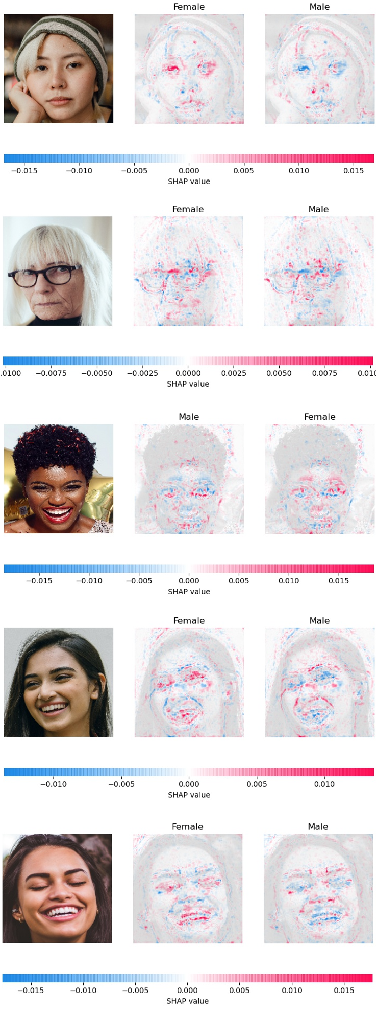

**SHAP Results – Inception V3 (female)**

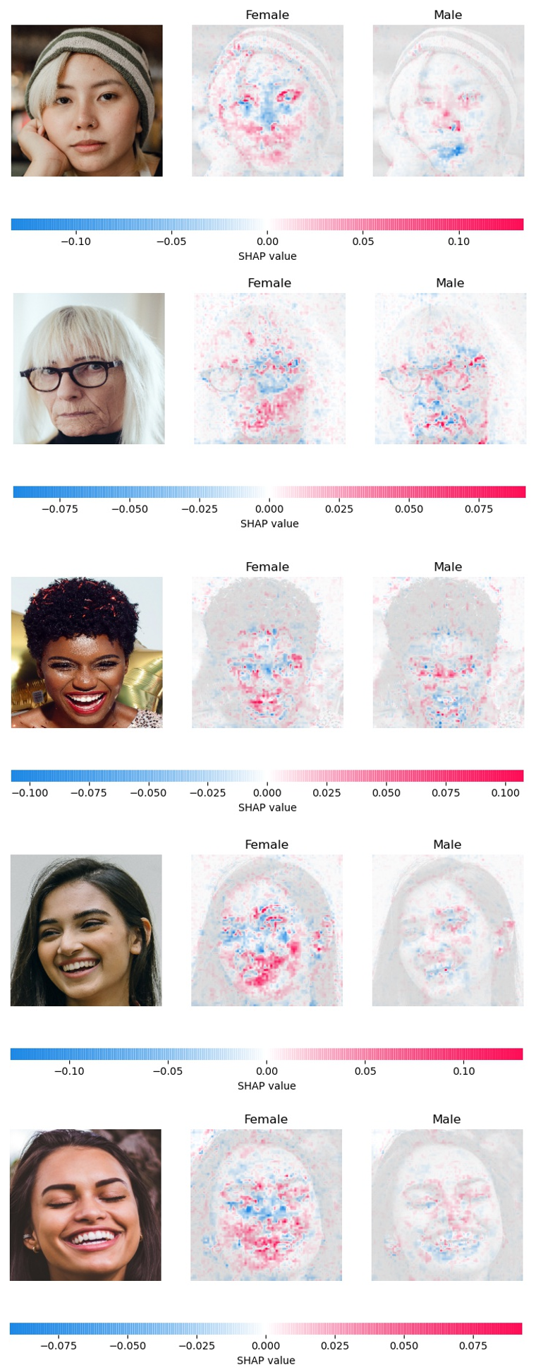

**SHAP Results – ResNet (female)**

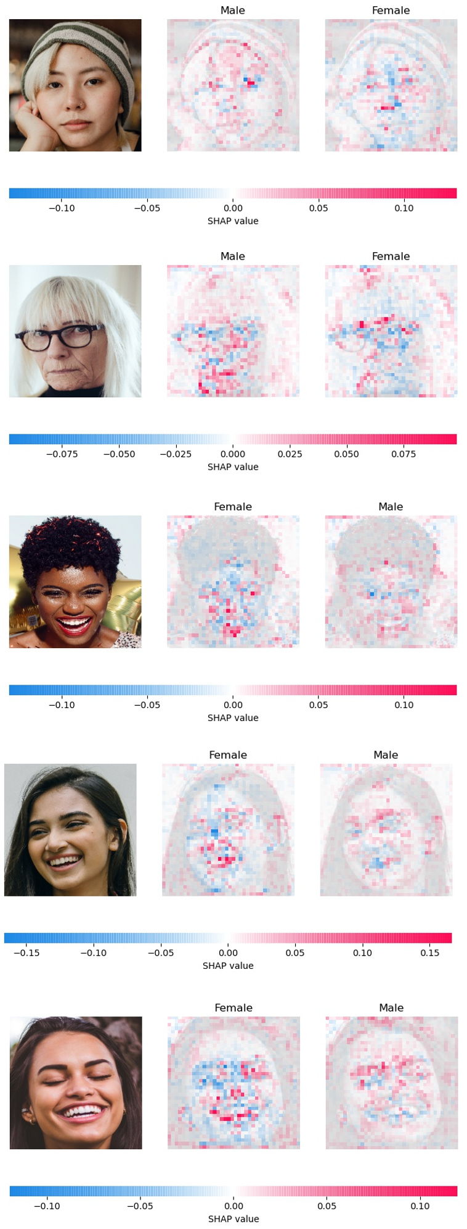

**SHAP Results – VGG-16 (male)**

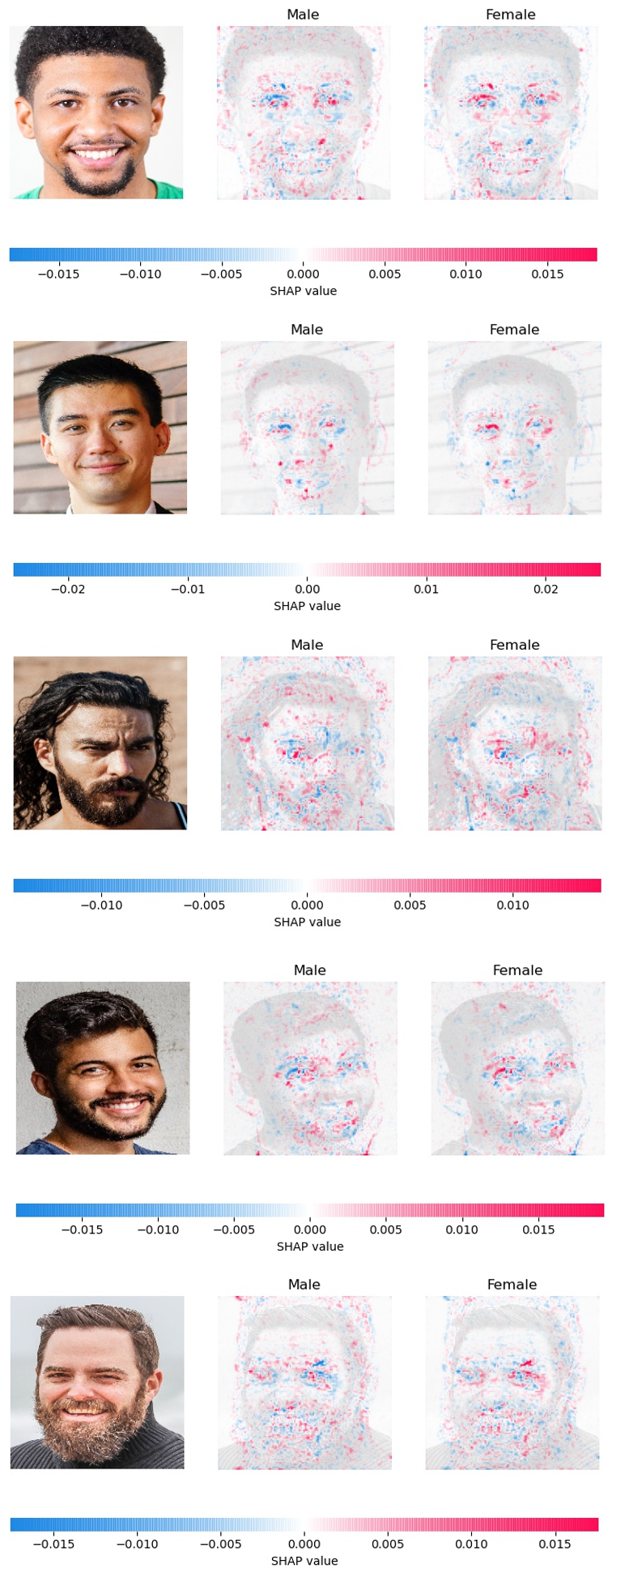

**SHAP Results – Inception V3 (male)**

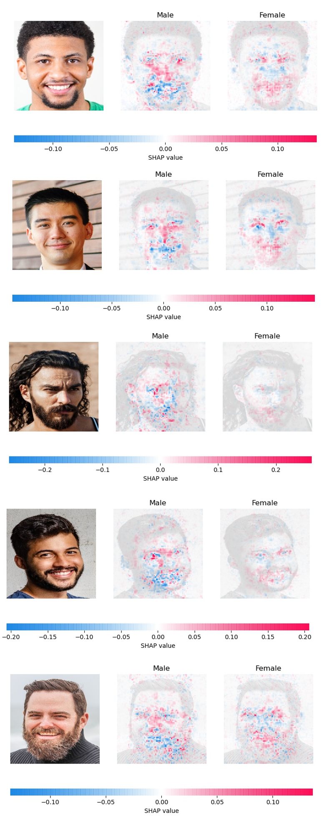

**SHAP Results – ResNet (male)**

